Sheboygan Falls Varsity Dance Team Winter Kids Clinic!
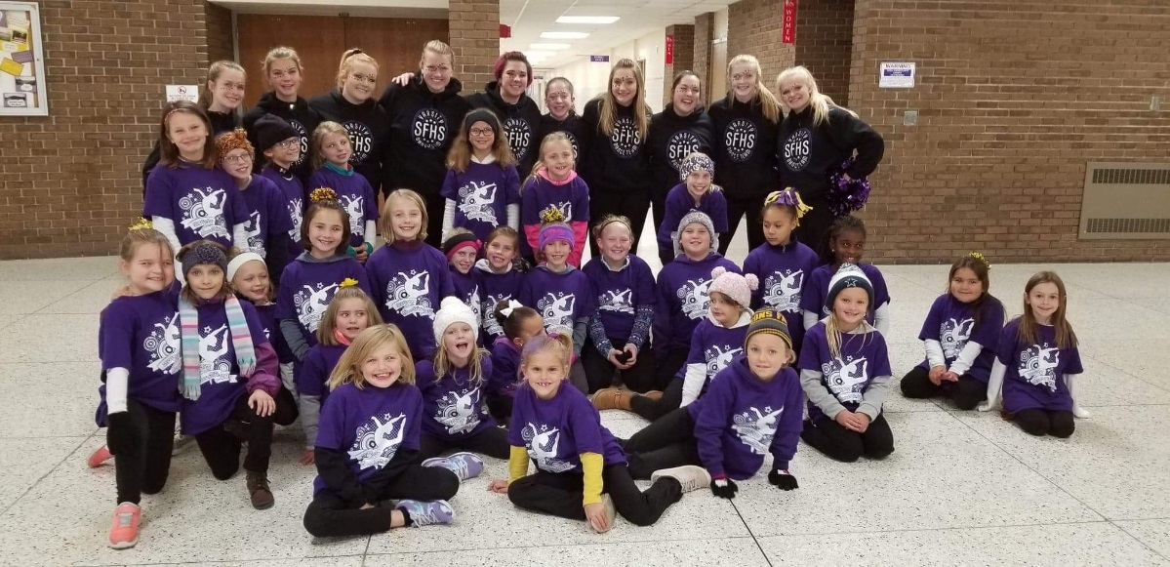

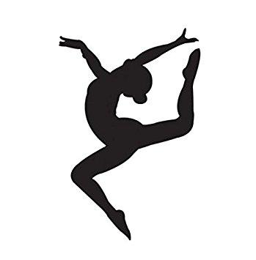

The Sheboygan Falls Varsity Dance Team invites your child, Kindergarten - 8th grade, to join us in our winter Kids Clinic! The cost is $25 per child, which includes a T-Shirt. Children will be in 3 groups, K-2nd grade, 3rd-5th grade & 6th through 8th grade. Each learn a routine that they will perform at a Varsity Basketball game! All proceeds will benefit the Varsity Dance Program.

Practices will be December 17th, 18th & 19th from 4pm-5pm at the high school (dance room & cafeteria).
Performance will be at halftime on December 20th (We will meet at 6:15pm for practice and sidelines!)
Please fill out the following information & turn it to the High school office (Attn: Alexis Kuehl) or email to: aakuehl@sheboyganfalls.k12.wi.us
Name: | Grade: | T- Shirt Size:
Parent/Guardian: | Phone: | Email:

