Sheboygan Falls Varsity Dance Team
Winter Kids Clinic!
DATE HAS CHANGED!!
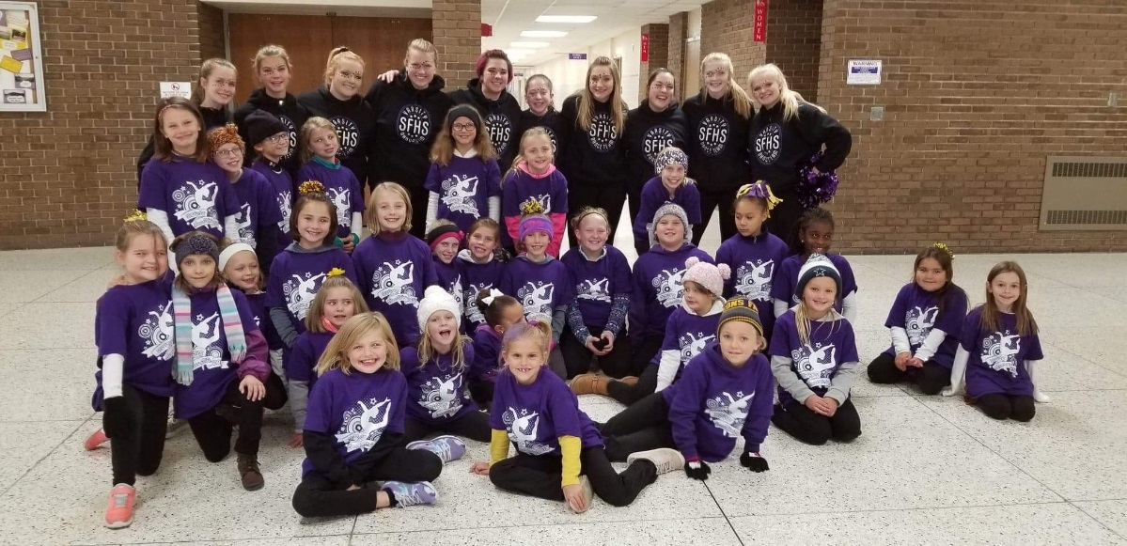

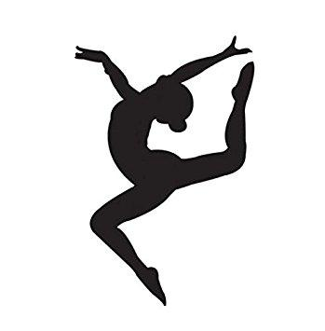

The Sheboygan Falls Varsity Dance Team invites your child (BOYS & GIRLS), Kindergarten - 8th grade, to join us in our winter Kids Clinic! The cost is $25 per child, which includes a T-Shirt. Children will be in 3 groups, K-2nd grade, 3rd-5th grade & 6th through 8th grade. Each learn a routine that they will perform at a Varsity Basketball game! All proceeds will benefit the Varsity Dance Program.

We will start at 4pm on January 15th to learn our routines and practice, have a pizza dinner and then perform at halftime of the Varsity Basketball game!

Please fill out the following information & turn it to the High school office (Attn: Alexis Kuehl) or email to: aakuehl@sheboyganfalls.k12.wi.us
Name: | Grade: | T- Shirt Size:
Parent/Guardian: | Phone: | Email:

