ATTENTION! Please REGISTER NOW for
Sheboygan Falls Elementary’s
fundraiser!
It’s super easy! Please help support our fundraiser by following the steps below to register online today. When you register, we’ll know you’re committed to supporting our fundraiser and helping us reach our goals. To help our organization even more, send 10 email invitations to friends & family and spread the word about our need for help. With over 2,500 gift ideas, supporters can shop and check-off their holiday gift-list, all while supporting our important cause.

Will you follow the instructions below and register today? It’s easy, it’s simple, and it’s important!

Here’s how to register today and help us spread the word!
Invite friends and family (even if they’re out of town), online orders ship directly to the purchaser!

Step 1: REGISTER at www.charlestonwrapstore.com
Organization ID:
19300
Participant Registration
(use organization ID to the left)

Step 2: Use our Email-Invite Generator to invite
out-of-town friends & family to shop and support!
Plus, share your unique invite links via text and
social media.

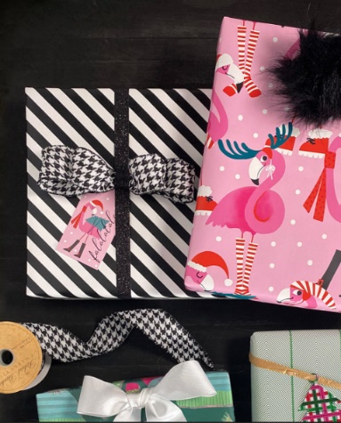
Ultra-Heavy Gift Wrap Personalization Holiday Décor Kitchen & Home

