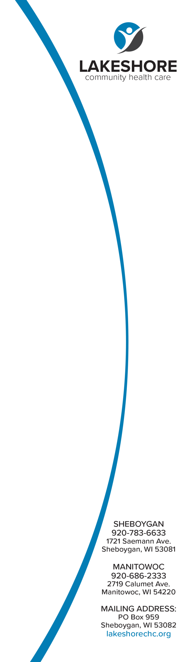

*Dear Families,*

*Lakeshore Community Health Care’s School Dental program is coming back to* ***Sheboygan Falls****for the 2021-2022 School Year!  We have implemented new safety measures to keep your student, school staff and us safe.  If you would like your child/children seen, please fill out a dental form, one for each child.  All forms are directly linked back to Lakeshore, just click on the link below and fill out the attached form! If you are unable to fill out the fillable form provided, these forms can also be picked up at Lakeshore Community Health Care at 1721 Saemann Avenue in Sheboygan****.  We must have a form filled out in order to see your student****.   If you have any questions about the dental program, please contact Katie at* [*shebschoolsdental@lakeshorechc.org*](mailto:shebschoolsdental@lakeshorechc.org?subject=School%20Dental%20Program%202021-2022) *or* **920-783-6633 Ext. 233**

***Fillable Form*** *:* <https://pdf.ac/nLv2j>

*( 1 form for each child that is participating,  Forms are only Valid for the 2021-2022 school year.  Forms filled out for previous schools years are expired and no longer valid.)*