CHRISTMAS ASSISTANCE

Each year The Salvation Army, thanks to this generous community, provides qualified area families with toys and gifts to ensure a Merry Christmas for all.  If you or someone you know is experiencing financial difficulties this Christmas, please visit the website below to learn more and sign up online. If you are unable to sign up online call 920-458-3723.   
Sign up available online Oct. 1 - Nov. 21

[www.SAsheboygan.org](http://www.SAsheboygan.org)

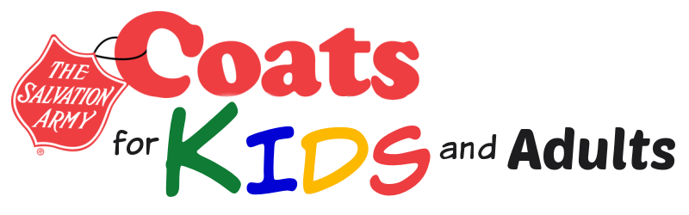

Warm winter wear is available to Sheboygan county children and adults thanks to the generosity of Reinbold-Novak Funeral Home's Coats for Kids collection. Please bring a photo identification card or piece of mail with your current address.  For more information call 920-458-3723.

**COAT DISTRIBUTION (ONE DAY ONLY)**

Thursday, Nov. 3 Noon - 7pm

at The Salvation Army Corps Community Center, 710 Pennsylvania

Ave. Sheboygan